Kafka Installation Doc
So, for mac users
First delete existing Kafka entries by following below steps.

Remove Previous Version
- Go to your kafka folder using command line and start zookeeper using command
bin/zookeeper-server-start.sh config/zookeeper.properties

- Now open one more terminal in the same location and run
bin/kafka-server-start.sh config/server.properties

- Now open one more terminal at the same location and run
bin/kafka-topics.sh --zookeeper localhost:2181 --delete --topic test
bin/kafka-topics.sh --zookeeper localhost:2181 --delete --topic response_topic
bin/kafka-topics.sh --zookeeper localhost:2181 --delete --topic post_book

- To check if all the topics are deleted run
bin/kafka-topics.sh --list --zookeeper localhost:2181

- This should return blank. If it returns topic_name –-mark for deletion then you will have to wait till it disappears.

- Once deletion is successful and no topic is listed
Terminate kafka ctrl+c by running in kafka window
Terminate zookeeper ctrl+c by running in zookeeper window

- Run lsof -i tcp:2181 in any new command line terminal
If you see any pid listed just delete those pids using

kill -9 pid(this will be pid number)
Example: kill -9 8171

- Now delete the entire kafka folder from your computer by doing move to trash.
- Delete any older kafka code that you have and terminate any kafka node servers if you are running any.

Now let’s start from fresh
- Download Kafka-Stable.zip

- It contains two zip files
kafka_2.11-1.1.0.zip and kafka.zip

- Unzip both the files.
- Open new terminal and get into kafka_2.11-1.1.0 folder using command line terminal and run
bin/zookeeper-server-start.sh config/zookeeper.properties
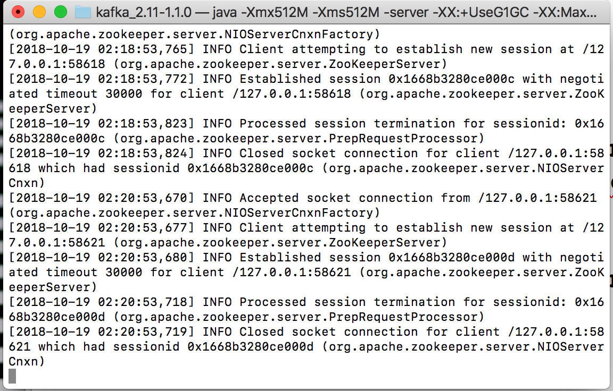

- Now open new terminal at the same location and run
bin/kafka-server-start.sh config/server.properties
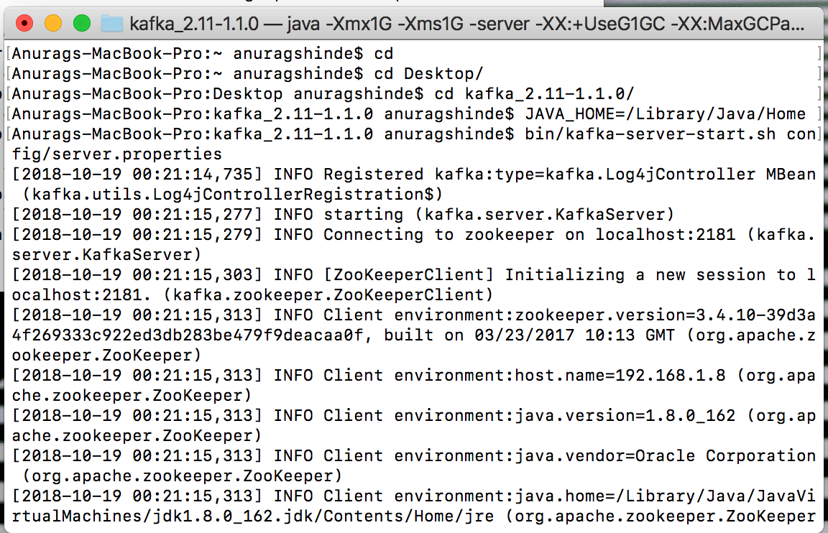

- Now open new terminal at the same location and run
- bin/kafka-topics.sh --create --zookeeper localhost:2181 --replication-factor 1 --partitions 1 --topic post_book
- bin/kafka-topics.sh --create --zookeeper localhost:2181 --replication-factor 1 --partitions 1 --topic response_topic

If you get topic already exist error, then follow deletion steps properly.

- Now run

bin/kafka-topics.sh --list --zookeeper localhost:2181

- Now Open new terminal,
Go to kafka (code) folder and go inside Backend folder using command line terminal
Run command : node index.js
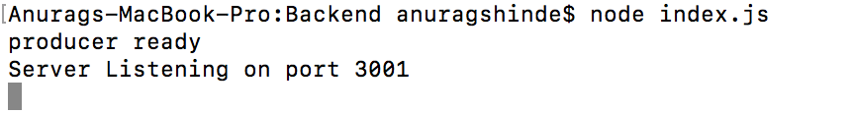

- Now open new terminal
Go to kafka (code) folder and go inside kafka-backend folder using command line terminal
Run command: npm start
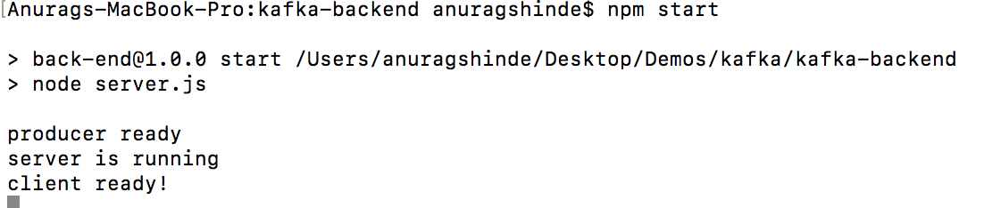

- Now open Postman enter the following details
{
"BookID" : "122",
"Title" : "Book 122",
"Author" : "Author 122"
}
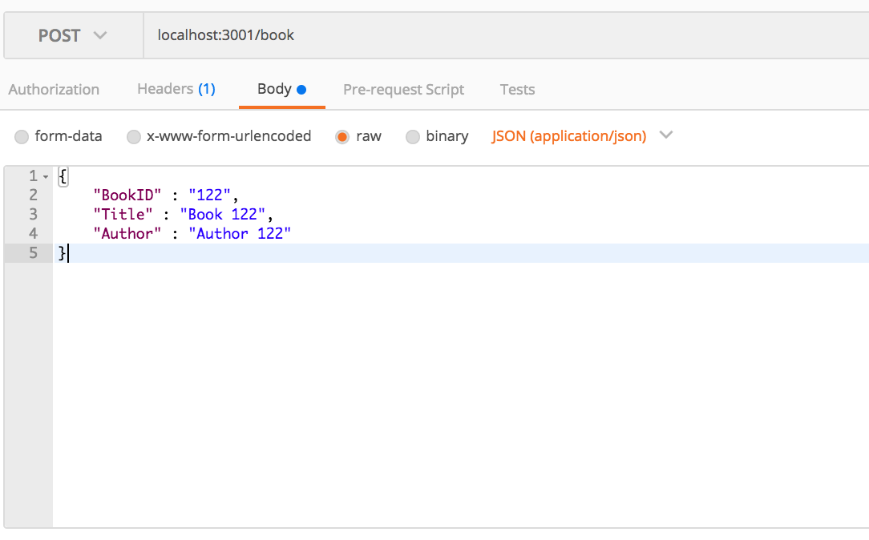

Use JSON(application/json) not text see the screenshot above.

- Click on send and you should be able to get below response.
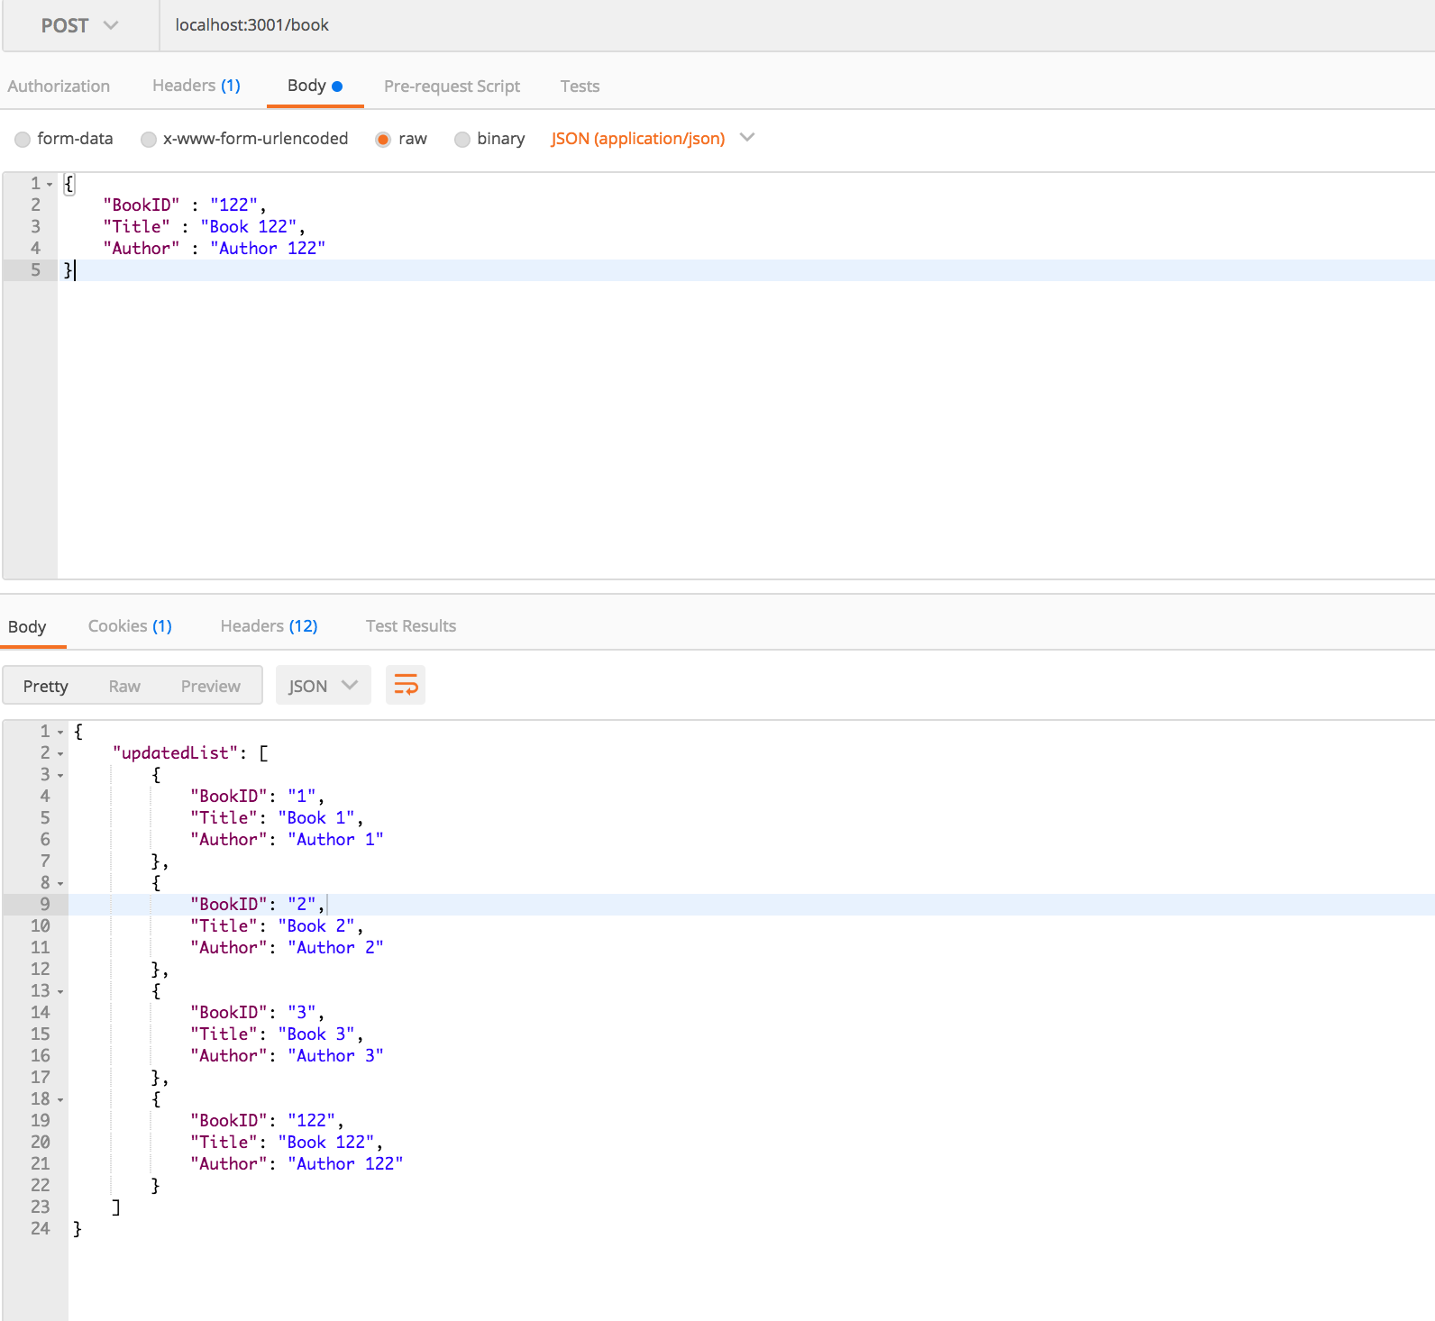

- For windows users
Install git bash and then you can use the above commands.
You will also have to download kafka_2.11-1.1.0 for windows. Hope it works for you but you face any difficulties please let us know. Rajiv will be your primary point of contact.

